1. Introduction
Project Title:
ShopEZ – MERN Stack E-Commerce Web Application
Introduction:
ShopEZ is a modern full-stack e-commerce web application developed using the MERN (MongoDB, Express.js, React.js, and Node.js) technology stack. The project is designed to provide users with a simple, secure, and user-friendly online shopping experience. It enables customers to create an account, log in securely, browse available products, manage their shopping cart, and place orders through an interactive web interface.
The rapid growth of online shopping has increased the demand for efficient and reliable e-commerce platforms. ShopEZ addresses this need by integrating frontend, backend, and database technologies into a single application that demonstrates the practical implementation of full-stack web development concepts.
The application focuses on providing a responsive user interface, secure authentication using JSON Web Tokens (JWT), efficient data management with MongoDB, and smooth communication between the client and server through RESTful APIs. This project also demonstrates how React components, Express routes, controllers, and MongoDB collections work together to build a real-world web application.
The main objective of this project is to enhance the understanding of full-stack development while creating a practical application that simulates an online shopping system.
Team Members:
Bagulakoti Abhigna.

2. Project Overview
Purpose:
The primary purpose of ShopEZ is to develop a complete MERN Stack-based e-commerce web application that provides users with a simple, secure, and efficient online shopping experience. The application allows customers to register, log in, browse products, manage their shopping cart, and place orders through a user-friendly interface.
The project also aims to demonstrate the practical implementation of full-stack web development by integrating React.js for the frontend, Node.js and Express.js for the backend, and MongoDB for database management. It provides hands-on experience in API development, authentication, database connectivity, version control using Git and GitHub, and complete project deployment workflow.

Additionally, the project helps students understand how real-world web applications are designed and developed by combining frontend technologies, backend services, and database operations into a single integrated system.

Features:
The ShopEZ application provides the following major features:
Secure User Registration
User Login using JWT Authentication
Responsive Home Page
Product Listing
Shopping Cart Management
Add Products to Cart
Increase Product Quantity
Decrease Product Quantity
Remove Products from Cart
Place Order Functionality
MongoDB Database Integration
REST API Communication
CRUD Operations (Create, Read, Update, Delete)
Responsive Navigation Bar
GitHub Repository Integration
Easy-to-use and User-Friendly Interface

3. Architecture

Frontend:
The frontend of the ShopEZ application is developed using React.js, a JavaScript library used for building interactive and responsive user interfaces. React follows a component-based architecture, which allows the application to be divided into reusable components, making the code more organized and maintainable.

React Router DOM is used for navigation between different pages such as Home, Login, Register, Products, and Cart. CSS is used to design the user interface with a clean blue-and-white theme, providing a professional and user-friendly experience. The frontend communicates with the backend through REST APIs to fetch product information, authenticate users, and manage cart and order operations.

The frontend provides users with a responsive interface that works efficiently on different screen sizes and devices.

Backend:

The backend of ShopEZ is developed using Node.js and Express.js. Node.js provides a JavaScript runtime environment that allows server-side programming, while Express.js simplifies API development and request handling.

The backend is responsible for processing user requests, handling authentication, validating user information, managing products, shopping cart operations, and order placement. RESTful APIs are created to establish communication between the frontend and the database.

JWT (JSON Web Token) authentication is implemented to ensure secure user login and authorization. The backend follows a modular structure consisting of routes, controllers, models, middleware, and configuration files, making the application scalable and easy to maintain.

Database:

The ShopEZ application uses MongoDB as its database management system. MongoDB is a NoSQL document-oriented database that stores data in JSON-like documents, providing flexibility and high performance.

Mongoose is used as an Object Data Modeling (ODM) library to define schemas and interact with MongoDB. The database stores user details, product information, shopping cart records, and order data efficiently.

The database enables quick retrieval and updating of information, ensuring smooth communication between the frontend and backend. MongoDB also supports scalability, making it suitable for future expansion of the application.

4. Setup Instructions

Prerequisites:
Before running the ShopEZ E-Commerce application, the following software and tools must be installed on the system:

• Node.js (JavaScript Runtime Environment)
• npm (Node Package Manager)
• Vite (Frontend Build Tool for React Application)
• MongoDB (Database)
• MongoDB Compass (Database GUI)
• Visual Studio Code (Code Editor)
• Git (Version Control System)
• GitHub Account (Repository Hosting)
• Modern Web Browser (Google Chrome or Microsoft Edge)

These software tools are required to successfully develop, run, and manage the ShopEZ application.

Installation:

Follow the steps below to install and set up the ShopEZ E-Commerce application:

Step 1:
Clone or download the ShopEZ project from the GitHub repository.

Step 2:
Open the project folder in Visual Studio Code.

Step 3:
Open the terminal and navigate to the client folder.

Step 4:
The frontend application is created and configured using Vite, which is a frontend build tool for React applications.

Step 5:
Install the frontend dependencies using the following command:

npm install

Step 6:
Open another terminal and navigate to the server folder.

Step 7:
Install the backend dependencies using the following command:

npm install

Step 8:
Configure the MongoDB database connection by providing the required database URL in the environment configuration file.

Step 9:
Start the backend server using the following command:

npm start

Step 10:
Start the React frontend application using the following command:

npm start

Step 11:
Open the application in the web browser using the localhost URL generated by React.

After completing these steps, the ShopEZ application will be ready for use.

Environment Variables:

The project uses environment variables to securely store sensitive configuration details.

The following environment variables are configured:

• MongoDB Connection URL
• JWT Secret Key
• Server Port Number

These variables are stored in the server configuration to ensure secure communication between the application and the database.

5. Folder Structure

The ShopEZ E-Commerce application follows a well-organized folder structure that separates the frontend and backend components. This structure improves code readability, maintainability, and scalability.

Client (React Frontend):

The client folder contains all the files related to the React.js frontend application. It is developed using Vite, which provides a fast and efficient development environment.

The frontend follows a component-based structure where different parts of the user interface are created as reusable components.

The main folders and files include:

• src/
- Contains the main source code of the React application.

• components/
- Contains reusable UI components such as navigation bar, product cards, and other interface elements.

• pages/
- Contains different application pages such as Home, Login, Register, Products, and Cart.

• assets/
- Stores images, icons, and other static resources used in the application.

• App.jsx
- The main React component that manages the application structure and routing.

• main.jsx
- The entry point of the React application where the application is rendered.

• package.json
- Contains frontend dependencies, scripts, and project configuration details.

The client folder is responsible for displaying the user interface and communicating with the backend through APIs.

Server (Node.js Backend):

The server folder contains all backend-related files developed using Node.js and Express.js. It handles application logic, API requests, authentication, and database operations.

The backend follows a modular structure to make the application easier to manage and expand.

The main folders and files include:

• routes/
- Contains API route definitions for authentication, products, cart, and orders.

• controllers/
- Contains the logic for handling API requests and generating responses.

• models/
- Contains MongoDB database schemas created using Mongoose.

• middleware/
- Contains authentication and request-processing middleware.

• config/
- Contains configuration files such as database connection settings.

• server.js
- The main entry point of the backend application that starts the Express server.

• package. json
- Contains backend dependencies and server-related scripts.

The server folder manages communication between the frontend and MongoDB database and provides secure API services for the application.

6. Running the Application

After completing the installation process and configuring the required dependencies, the ShopEZ E-Commerce application can be started locally by running the frontend and backend servers separately.

Frontend:

The frontend of the ShopEZ application is developed using React.js with Vite. To start the frontend server, follow the steps below:

Step 1:
Open the terminal and navigate to the client directory.

Command:
cd client

Step 2:
Install the required dependencies (if not already installed).

Command:
npm install

Step 3:
Start the React frontend application using the Vite development server.

Command:
npm run dev

After successful execution, the frontend application will run on the local development server and can be accessed through the browser.

Backend:

The backend of the ShopEZ application is developed using Node.js and Express.js. To start the backend server, follow the steps below:

Step 1:
Open a new terminal and navigate to the server directory.

Command:
cd server

Step 2:
Install the required backend dependencies.

Command:
npm install

Step 3:
Start the backend server using the following command:
npm start

After successful execution, the backend server will start and handle API requests from the frontend application.

The frontend and backend servers work together to provide complete functionality of the ShopEZ E-Commerce application.

7. API Documentation

The ShopEZ E-Commerce application uses RESTful APIs to enable communication between the React frontend and the Node.js backend. The backend exposes different API endpoints for user authentication, product management, cart operations, and order processing.

Each API endpoint accepts requests from the frontend, processes the required operations, communicates with the MongoDB database, and returns appropriate responses.

Authentication Endpoints

User Registration

Endpoint:

POST /api/auth/register

Description:

This endpoint is used to create a new user account in the application.

Request Method:

POST

Parameters:

- Name
- Email
- Password

Example Request:

{
"name": "User Name",
"email": "user@gmail.com",
"password": "password123"
}

Example Response:

{
"message": "User registered successfully"
}

User Login

Endpoint:

POST /api/auth/login

Description:

This endpoint authenticates existing users and provides access to protected features.

Request Method:

POST

Parameters:

- Email
- Password

Example Request:

{
"email": "user@gmail.com",
"password": "password123"
}

Example Response:

{
"message": "Login successful",
"token": "JWT token"
}

Product Endpoints

Get Products

Endpoint:

GET /api/products

Description:

This endpoint retrieves the list of available products from the database.

Request Method:

GET

Parameters:

No parameters required.

Example Response:

[
{
"name": "Product Name",
"price": 500,
"description": "Product details"
}
]

Cart Endpoints

Add Product to Cart

Endpoint:

POST /api/cart/add

Description:

This endpoint allows users to add selected products to their shopping cart.

Request Method:

POST

Parameters:

- Product ID
- Quantity
- User ID

Example Response:

{
"message": "Product added to cart"
}

Update Cart Quantity

Endpoint:

PUT /api/cart/update

Description:

This endpoint updates the quantity of products present in the cart.

Request Method:

PUT

Parameters:

- Product ID
- Updated Quantity

Example Response:

{
"message": "Cart updated successfully"
}

Remove Product from Cart

Endpoint:

DELETE /api/cart/remove

Description:

This endpoint removes a selected product from the user's cart.

Request Method:

DELETE

Parameters:

- Product ID
- User ID

Example Response:

{
"message": "Product removed from cart"
}

Order Endpoint

Place Order

Endpoint:

POST /api/orders/place

Description:

This endpoint is used to place an order for the products available in the cart.

Request Method:

POST

Parameters:

- User ID
- Cart Items
- Order Details

Example Response:

{
"message": "Order placed successfully"
}

8. Authentication

Authentication and authorization are important security features implemented in the ShopEZ E-Commerce application to protect user information and control access to application features.

Authentication and Authorization Handling

The ShopEZ application uses secure user authentication to verify the identity of users before allowing them to access protected features. Users must register an account and provide valid login credentials to access the application.

During registration, user details such as name, email, and password are stored securely in the MongoDB database. During login, the entered credentials are verified with the stored user information. If the credentials are valid, the user is authenticated successfully.

Authorization is handled by allowing only authenticated users to access certain operations such as cart management and order placement. Middleware functions are used in the backend to verify user identity before processing protected API requests.

Tokens and Security Methods Used

The application uses **JSON Web Token (JWT)** for secure authentication and authorization. After successful login, the backend generates a JWT token and sends it to the frontend.

The token is stored on the client side and is included with future requests to access protected backend routes. The backend verifies the token using authentication middleware before allowing access to protected resources.

JWT helps maintain secure communication between the frontend and backend without requiring users to log in repeatedly for every request.

Additional security methods used in the application include:

• Password protection during user authentication.
• Token-based verification for protected routes.
• Middleware-based authorization.
• Secure communication between frontend and backend APIs.
• Validation of user requests before performing operations.

These authentication mechanisms help ensure that user data and application resources remain secure.

9. User Interface

The user interface of the ShopEZ E-Commerce application is designed to provide a simple, attractive, and user-friendly shopping experience. The frontend is developed using React.js with a clean blue-and-white theme to maintain a professional appearance.

The application provides smooth navigation between different pages and allows users to easily access shopping features such as browsing products, managing the cart, and placing orders.

The following screenshots showcase the major user interface features of the ShopEZ application:

Home Page
The Home Page is the main landing page of the application. It contains the navigation bar and provides users with access to different sections of the application such as Home, Products, Login, and Cart.

Screenshot:
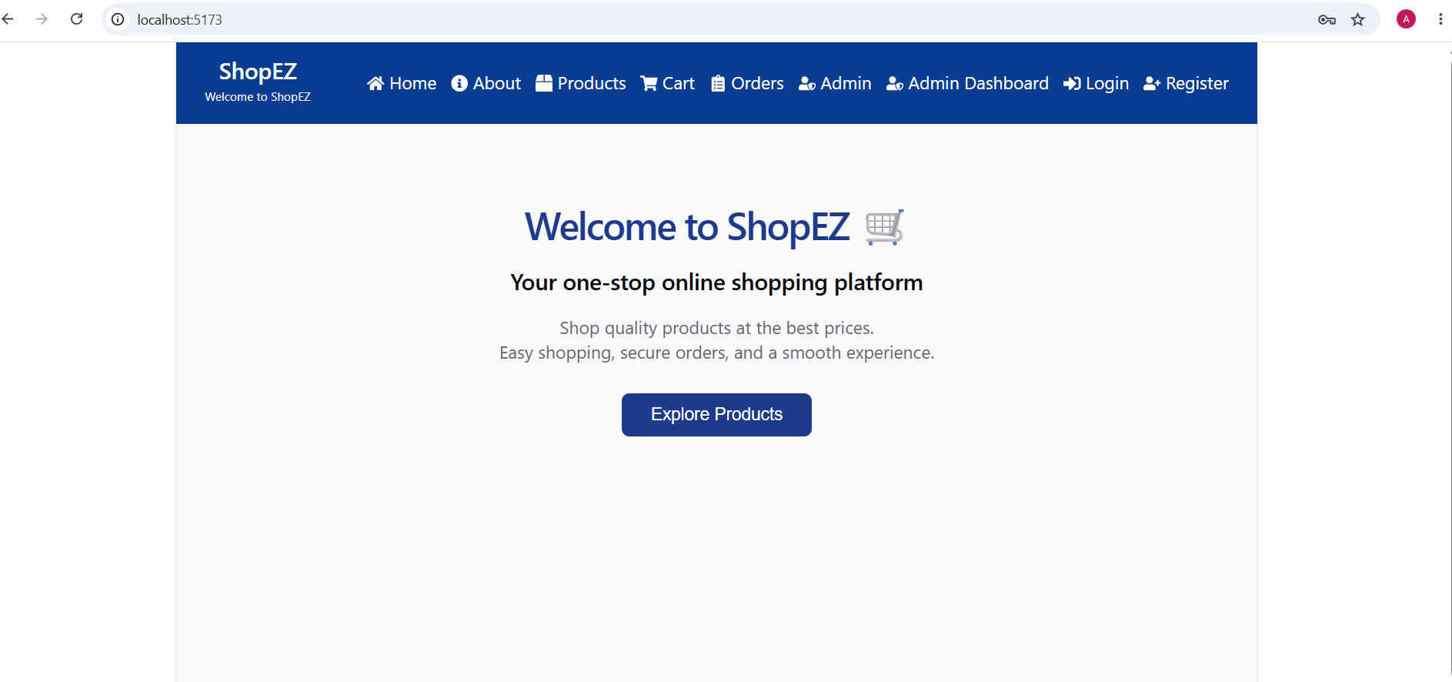

User Registration Page
The Registration Page allows new users to create an account by entering required details. User information is securely stored in the database after successful registration.

Screenshot:
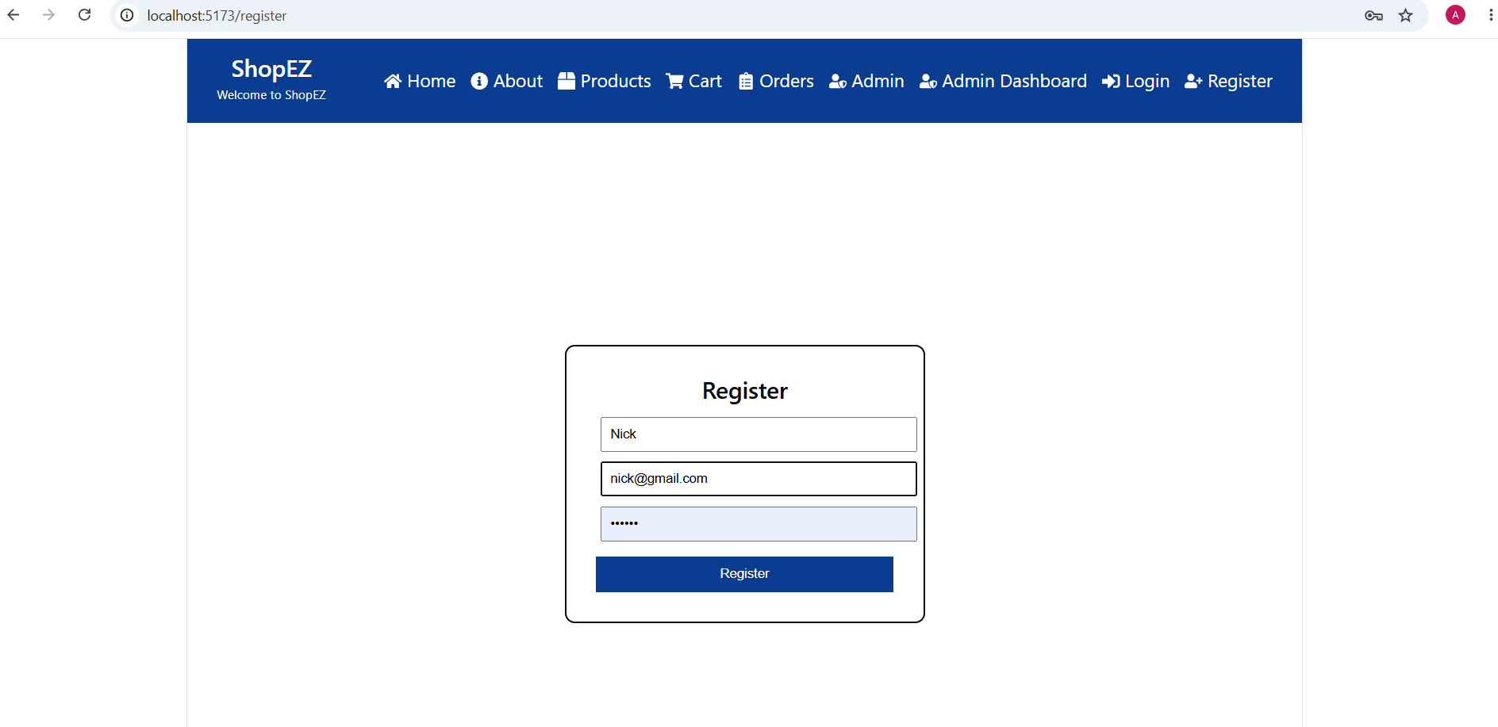
User Login Page

The Login Page allows existing users to authenticate themselves using their registered email and password. After successful login, users can access protected features of the application.

Screenshot:
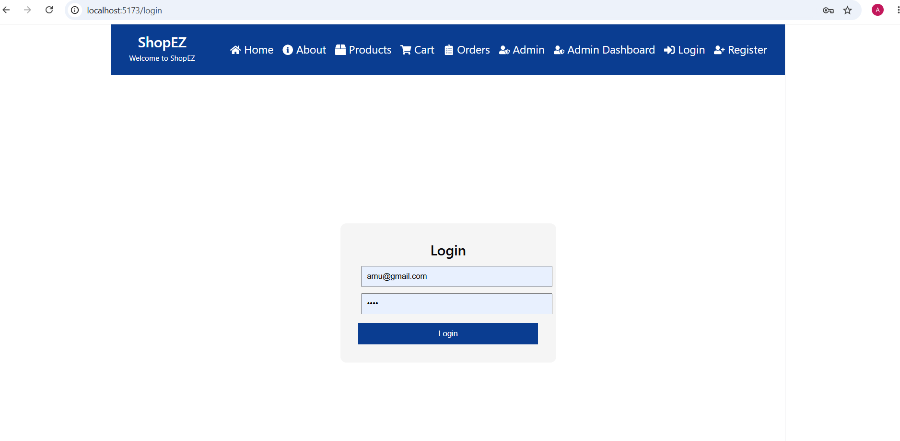

Product Listing Page
The Product Page displays the available products with necessary details. Users can view products and select items they want to purchase.

Screenshot:
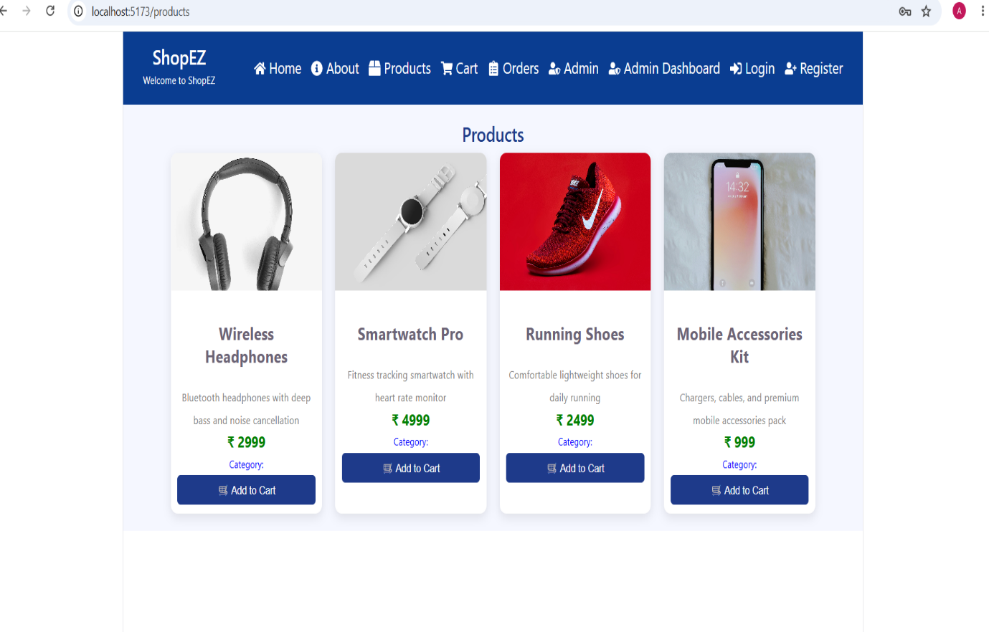

Shopping Cart Page

The Cart Page allows users to manage selected products. Users can increase quantity, decrease quantity, remove products, and view cart details before placing an order.
Screenshot:
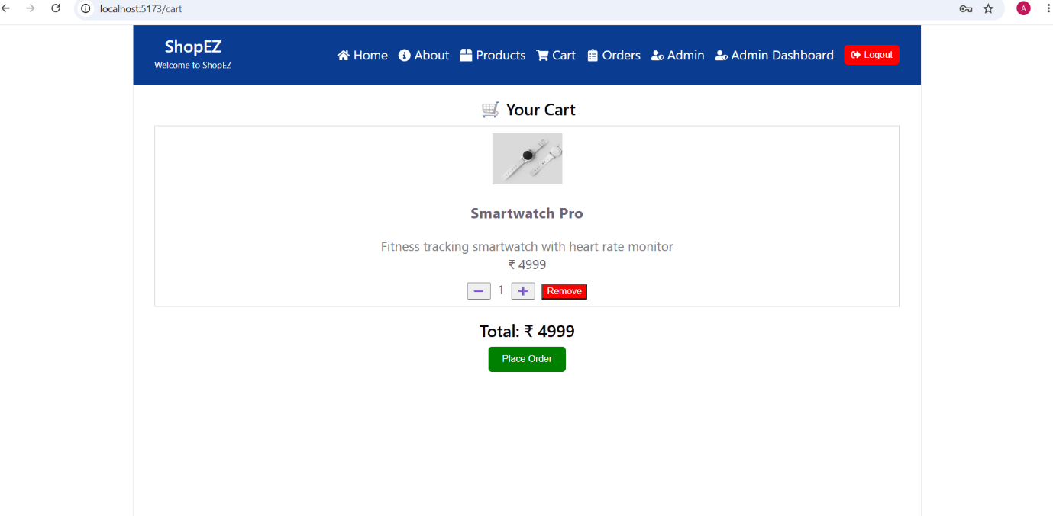

Order Placement Page

The Order Page allows users to confirm and place their orders. After successful order placement, the application displays the order confirmation message.

Screenshot:
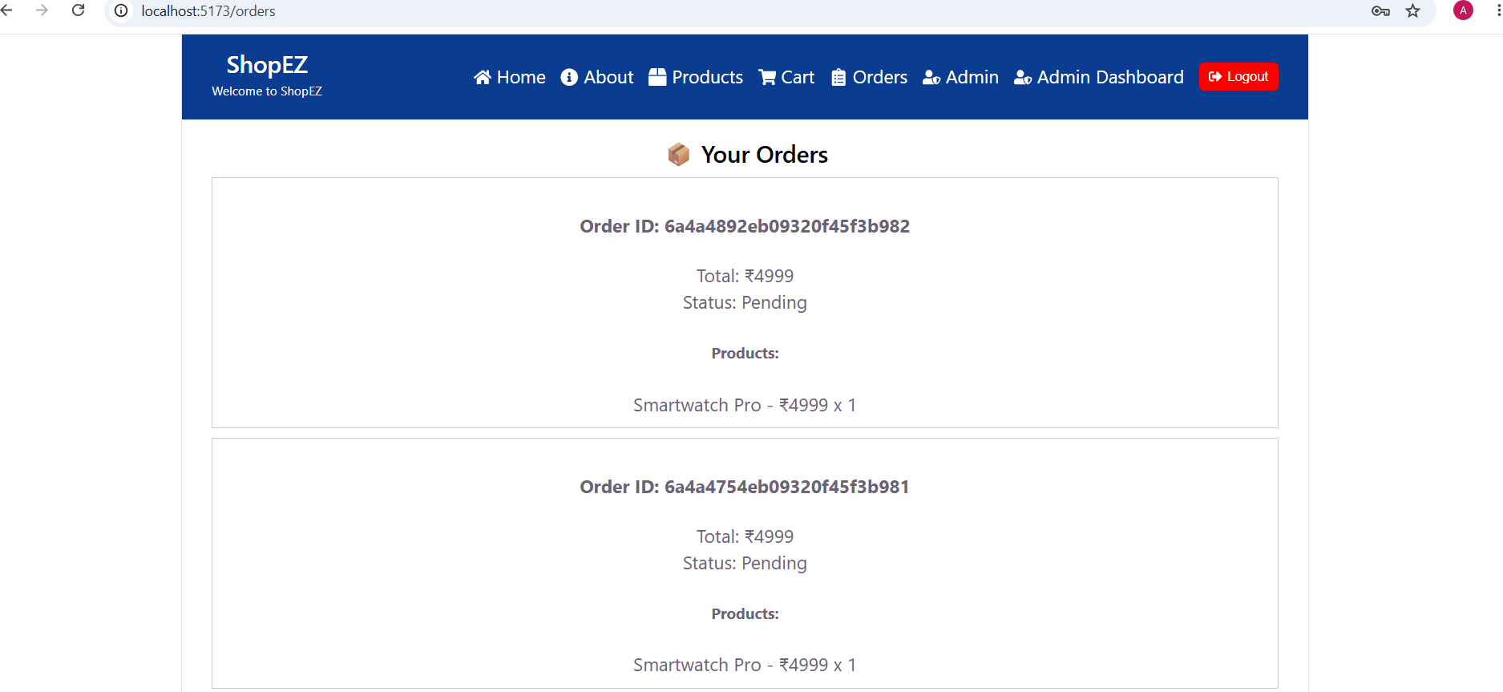

Admin Login:
This module provides secure access for administrators. After successful login, the administrator can access the Admin Dashboard to manage products and orders. The Admin Dashboard screenshot is omitted because it displays information already shown in the Products and Orders modules.
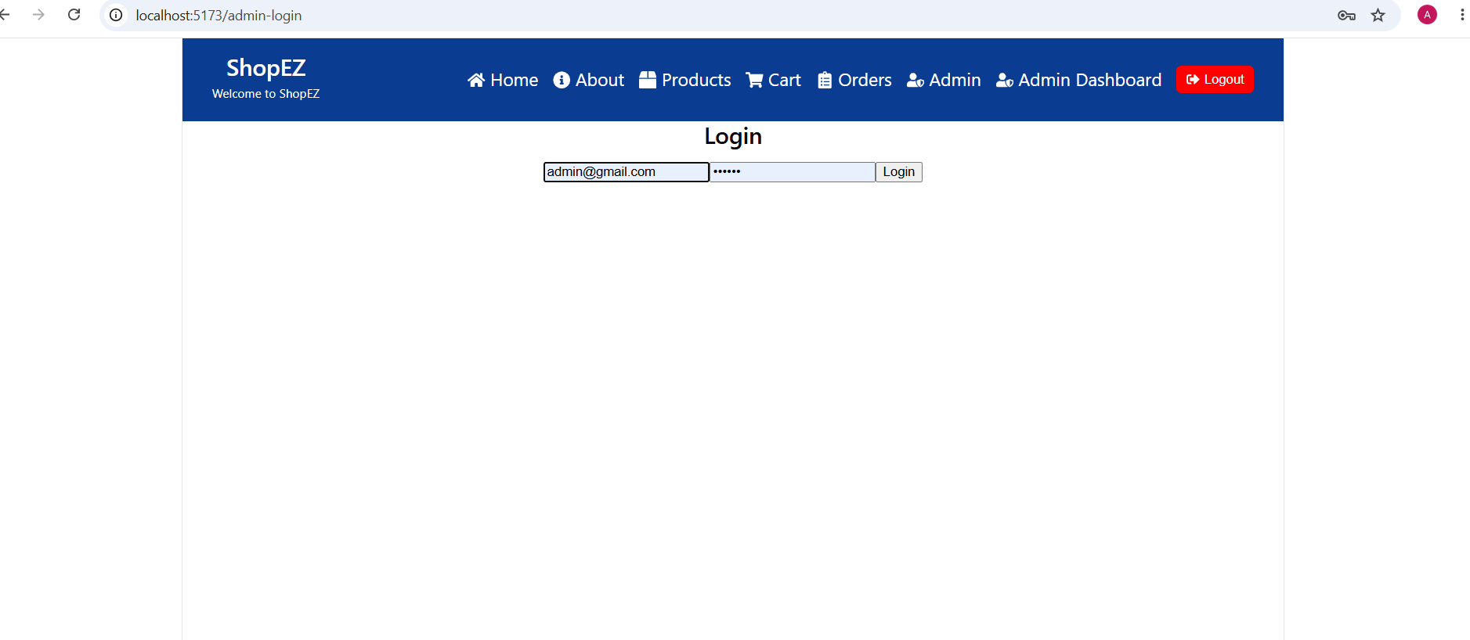

UI Features Summary
The main user interface features of ShopEZ include:

• Clean and responsive design.
• Easy navigation using the top navigation bar.
• User-friendly authentication pages.
• Product display interface.
• Interactive shopping cart operations.
• Simple order placement process.
• Consistent blue-and-white theme across the application.

10. Testing

Testing is an important phase in the development of the ShopEZ E-Commerce application. It ensures that all features of the application work correctly and that the system provides a reliable and error-free user experience.

Testing Strategy

The ShopEZ application follows a manual testing approach to verify the functionality of both frontend and backend components.

The testing process includes checking individual features, validating user interactions, and ensuring proper communication between the React frontend, Node.js backend, and MongoDB database.

The following testing activities were performed:

• Functional Testing:
The main functionalities of the application were tested to ensure that each feature works according to the requirements.

• User Authentication Testing:
Registration and login functionalities were tested by providing valid and invalid user credentials.

• Product Testing:
Product listing and product information display were verified to ensure correct data retrieval from the database.

• Cart Testing:
Shopping cart operations such as adding products, increasing quantity, decreasing quantity, and removing products were tested.

• Order Testing:
The order placement functionality was tested to verify successful order processing.

• API Testing:
Backend REST APIs were tested to ensure proper request handling and correct responses between frontend and backend.

• Database Testing:
MongoDB database operations were checked to ensure that user, product, cart, and order data were stored and retrieved correctly.

Tools Used for Testing

The following tools and technologies were used during the testing process:

• Visual Studio Code:
Used for running the application, monitoring errors, and debugging code.

• Web Browser (Google Chrome):
Used for testing the user interface and checking application behavior.

• Postman:
Used for testing backend REST APIs and verifying API requests and responses.

• MongoDB Compass:
Used for checking database collections and verifying stored data.

• Git and GitHub:
Used for version control and maintaining different versions of the project.

The testing process helped ensure that the ShopEZ application functions correctly and provides a smooth experience for users.

11. Screenshots / Demo

The ShopEZ E-Commerce application was successfully developed and tested. The following screenshots demonstrate the major features and working flow of the application.

Screenshots of the application are included below to showcase the user interface and functionality:

Application Screenshots

Home Page

The Home Page displays the main interface of the ShopEZ application. It provides easy navigation to different sections such as Home, Products, Login, and Cart.



User Registration and Login

The Registration and Login pages allow users to create an account and securely access the application.

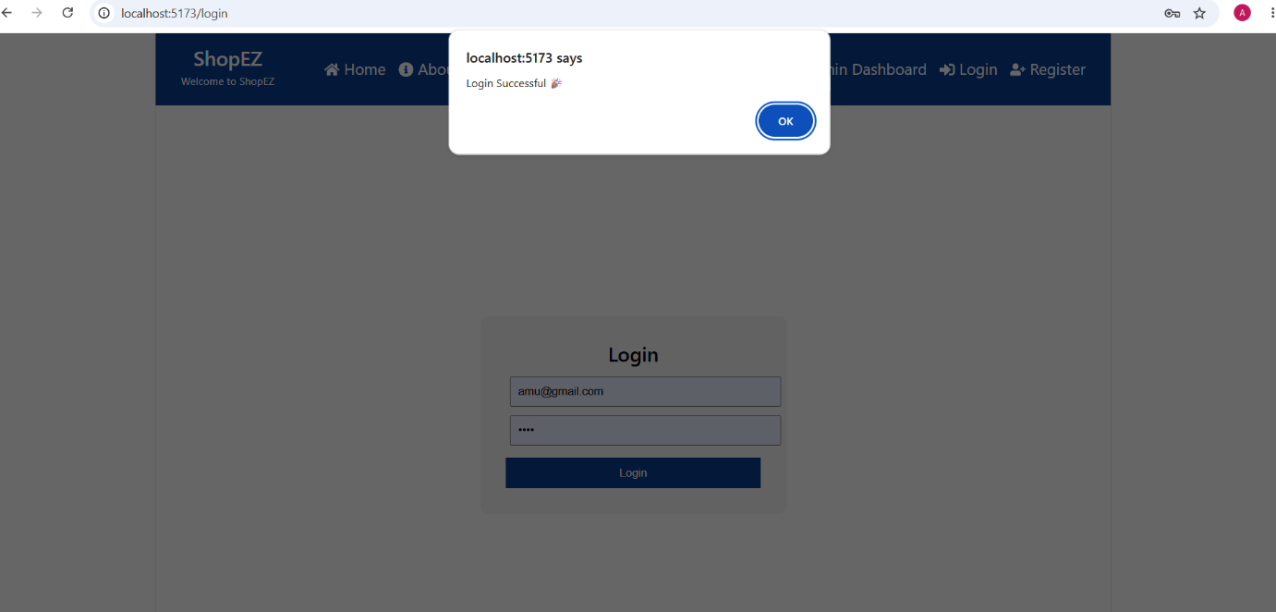
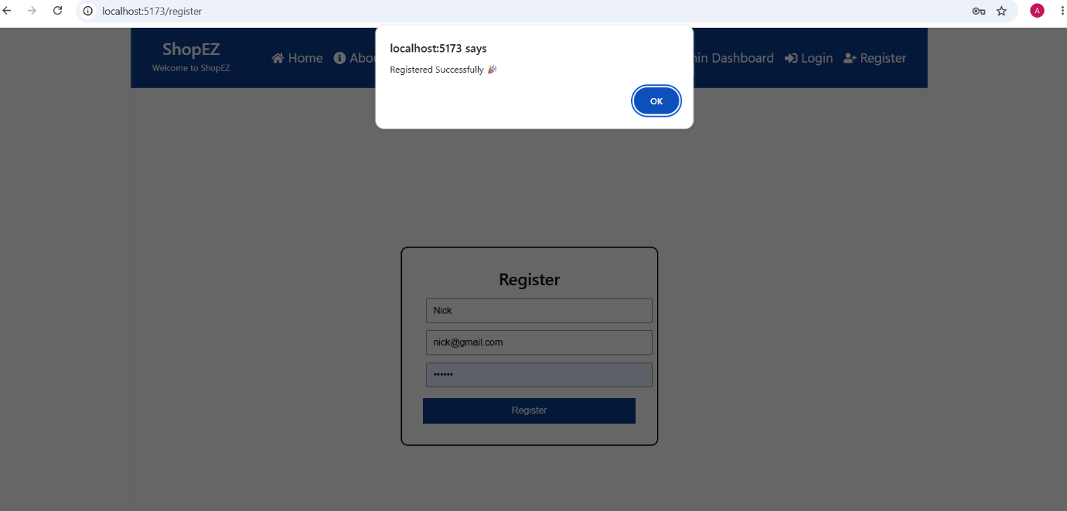
Product Listing

The Product Listing page displays available products with relevant details and allows users to select products for shopping.

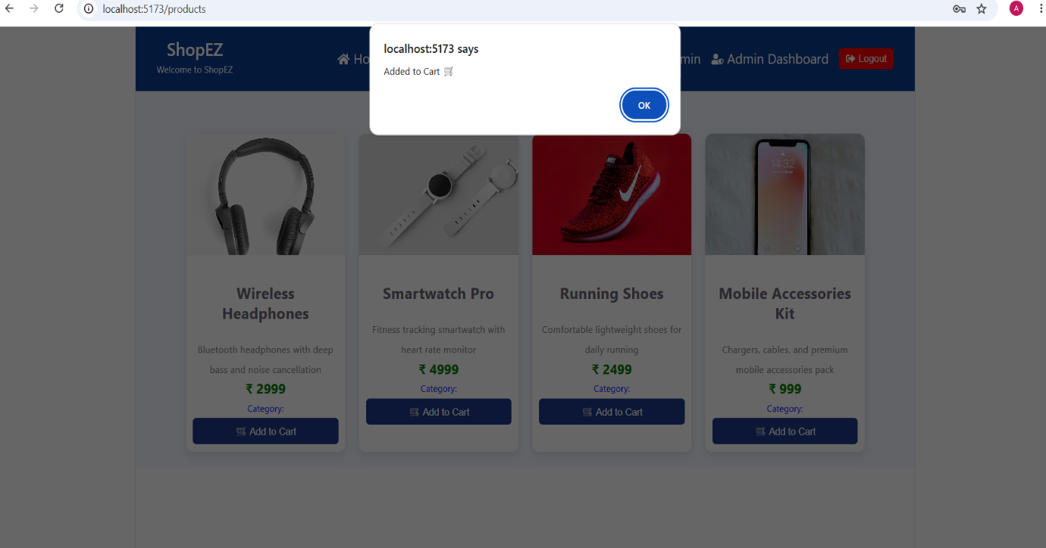

Shopping Cart

The Shopping Cart page allows users to view selected products, modify quantities, remove items, and proceed with order placement.
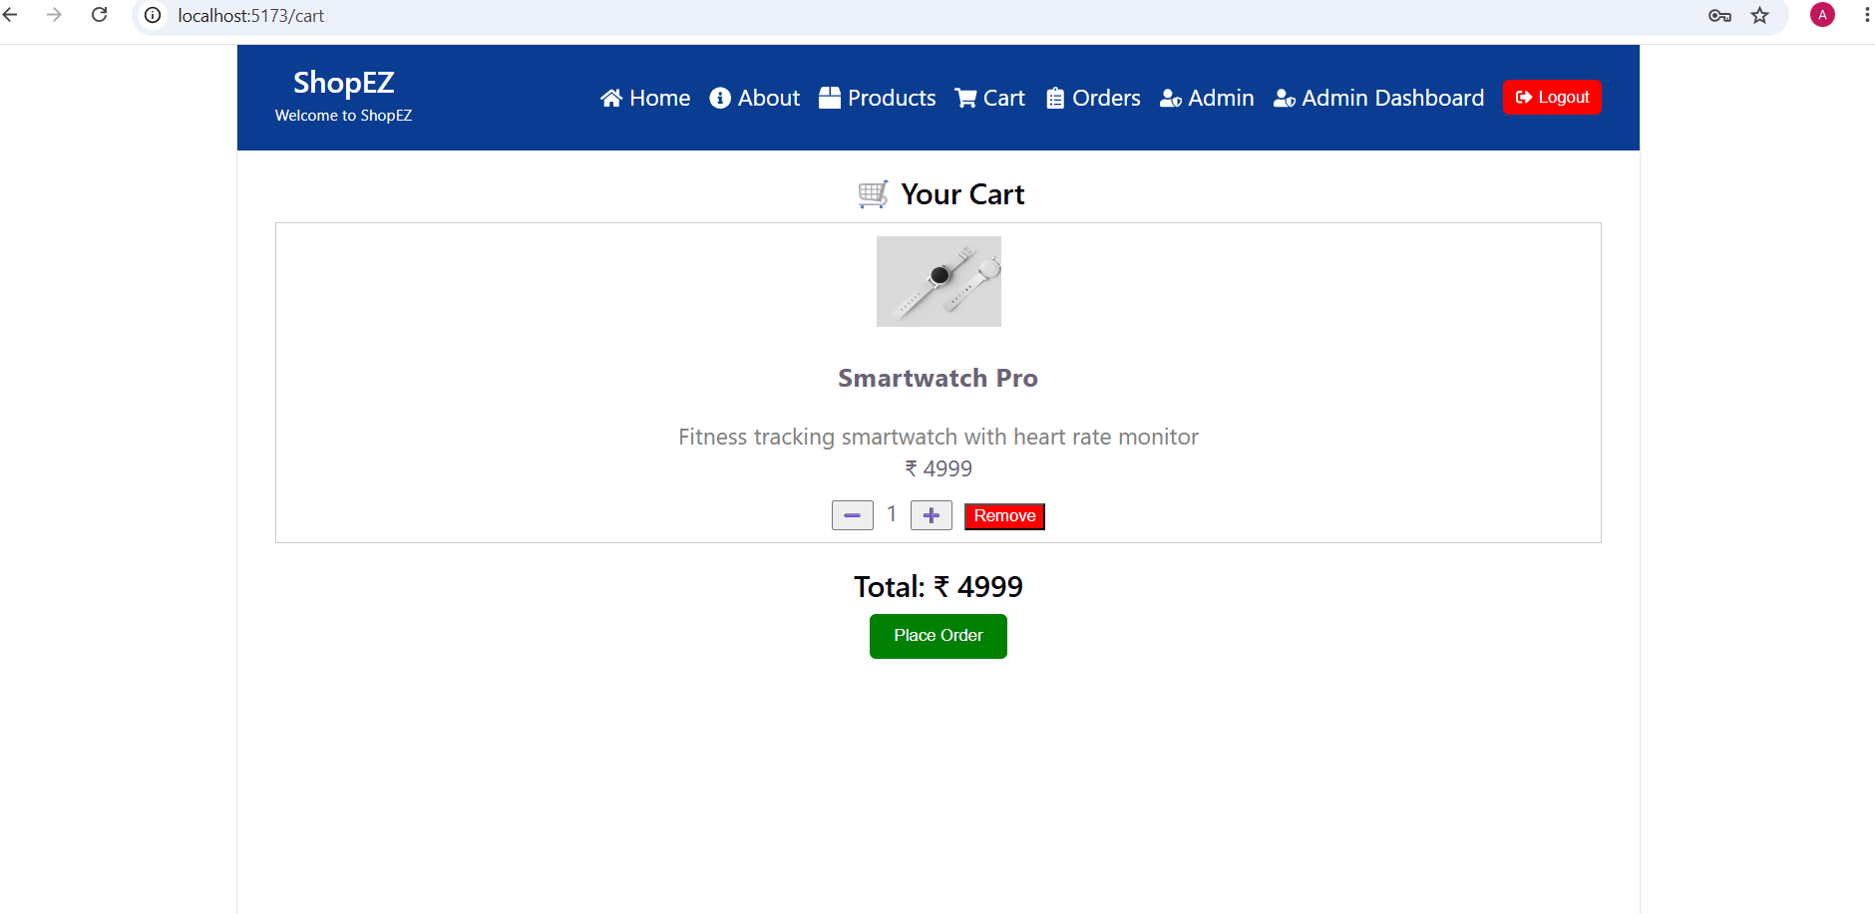

Order Placement

The Order Placement page demonstrates the process of confirming and successfully placing an order.

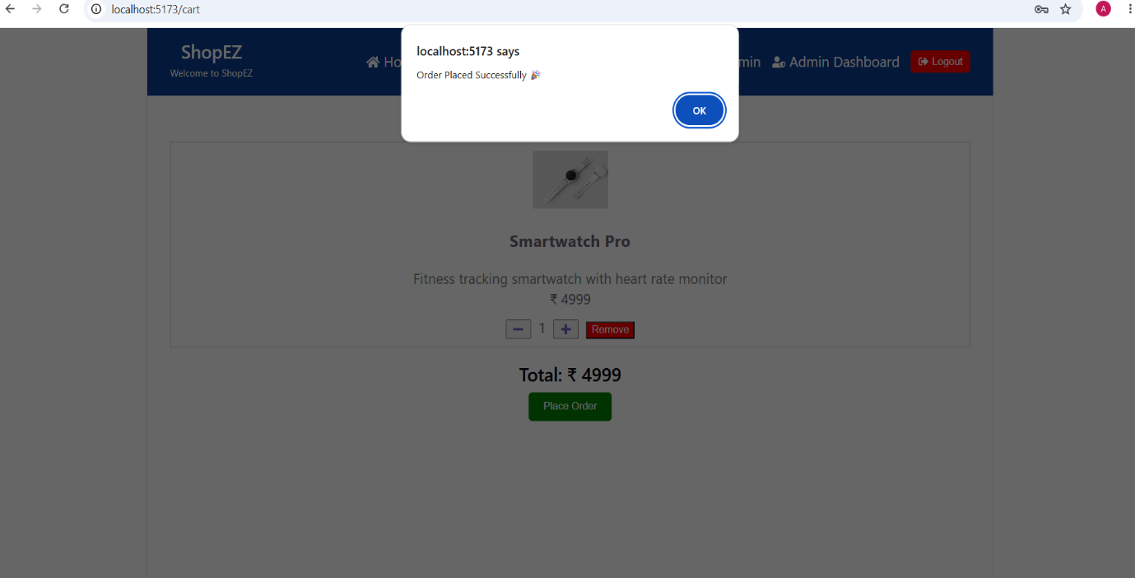
About Page

The About Page provides information about the ShopEZ E-Commerce application, including its purpose, objectives, technologies used, and project details. It helps users understand the application's functionality and development background.

Screenshot:
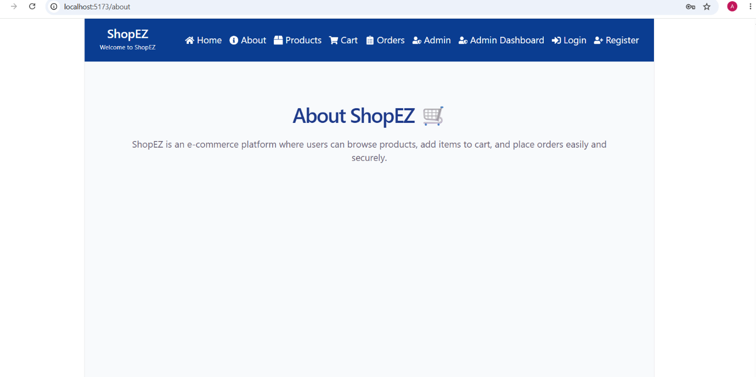

Admin Login: This module provides secure access for administrators. After successful login, the administrator can access the Admin Dashboard to manage products and orders. The Admin Dashboard screenshot is omitted because it displays information already shown in the Products and Orders modules.
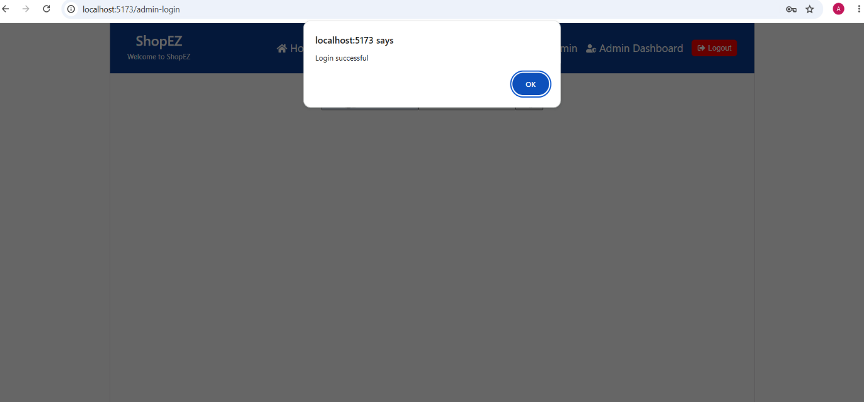

Logout Successfully

The Logout feature allows users to securely exit from the ShopEZ application. After successful logout, the user session is terminated and the application redirects the user to the Home or Login page.

Screenshot:
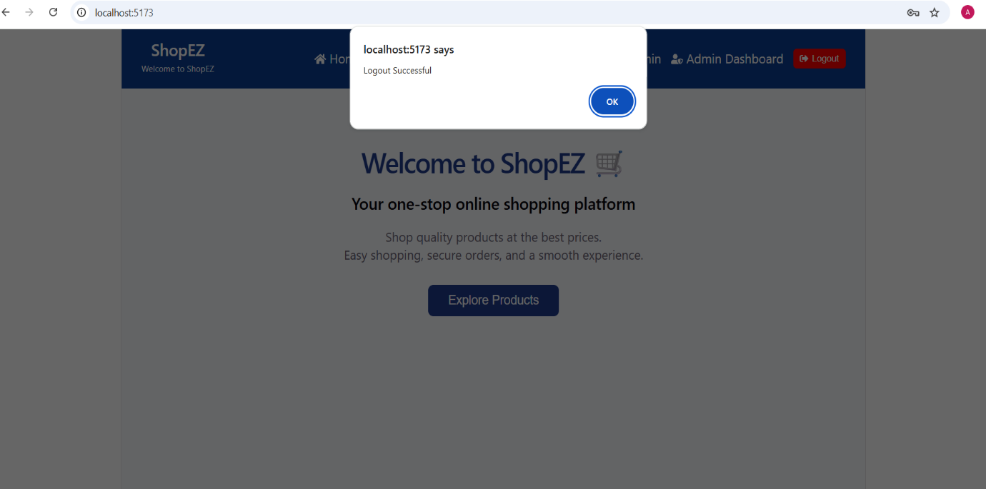

Demo Link
The complete source code of the ShopEZ E-Commerce application is available in the GitHub repository.

GitHub Repository Link:
https://github.com/abhigna19006/ShopEZ-E-commerce.git

A project demonstration video can also be provided to showcase the complete working flow of the application, including user authentication, product browsing, cart management, and order placement.

Demo Video Link:
https://drive.google.com/file/d/11GksOdpNWi-LMXOfatzBb1PI_hpgj3e7/view?usp=sharing

12. Known Issues

Although the ShopEZ E-Commerce application has been successfully developed and tested, some limitations and minor issues may exist in the current version of the application.

The following are the known issues and limitations:

• Payment Gateway is not implemented:
The current version does not include online payment integration. Orders can be placed through the application, but payment processing functionality is not available.

• Limited Product Management:
The application currently displays predefined products. An admin panel for adding, updating, and deleting products dynamically is not implemented.

• Search and Filter Options:
The application does not currently provide advanced product search and filtering options. Users need to browse the available products manually.

• Order Tracking:
The current version does not include real-time order tracking functionality after order placement.

• User Profile Management:
Features such as updating user profile details and managing account information are not included in the current version.

• Limited Error Handling:
Some advanced error messages and validation improvements can be added in future updates to provide a better user experience.

These issues do not affect the core functionality of the ShopEZ application. The existing features such as authentication, product display, cart management, and order placement work successfully.

13. Future Enhancements

The ShopEZ E-Commerce application provides essential online shopping features such as user authentication, product browsing, cart management, and order placement. In the future, the application can be enhanced by adding more advanced features to improve user experience, security, and scalability.

The following are the possible future enhancements:

• Online Payment Integration:
A secure payment gateway can be integrated to allow users to complete online payments using debit cards, credit cards, UPI, and other payment methods.

• Advanced Product Search and Filtering:
Search functionality and filtering options can be added to help users quickly find products based on categories, price range, ratings, and availability.

• Product Reviews and Ratings:
Users can be allowed to provide reviews and ratings for products, helping other customers make better purchasing decisions.

• Order Tracking System:
A real-time order tracking feature can be implemented to allow users to monitor their order status from placement to delivery.

• Wishlist Feature:
A wishlist option can be added so that users can save their favorite products and purchase them later.

• Improved User Profile Management:
Users can be provided with options to update personal information, manage addresses, and view order history.

• Enhanced Security Features:
Additional security improvements such as advanced encryption, two-factor authentication, and improved data protection can be implemented.

• Cloud Deployment:
The application can be deployed on cloud platforms to improve availability, performance, and scalability.

These future enhancements will help transform ShopEZ into a more complete, secure, and scalable e-commerce platform.

